MVCI Pre-calling process

Every Monday between 12:00pm and 2:00pm E.S.T. a file extracted from MARSHA with the arrivals 30 days out will be added to your database. This process will show you how to extract those arrivals using CA as well as how to follow up with the whole pre-calling process.

STEP 1
From the profiles screen click import profiles

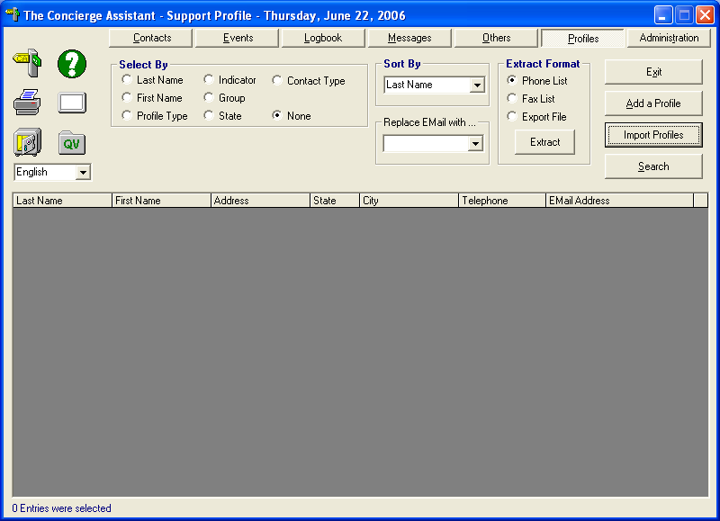

You will be asked if you want to import the profiles

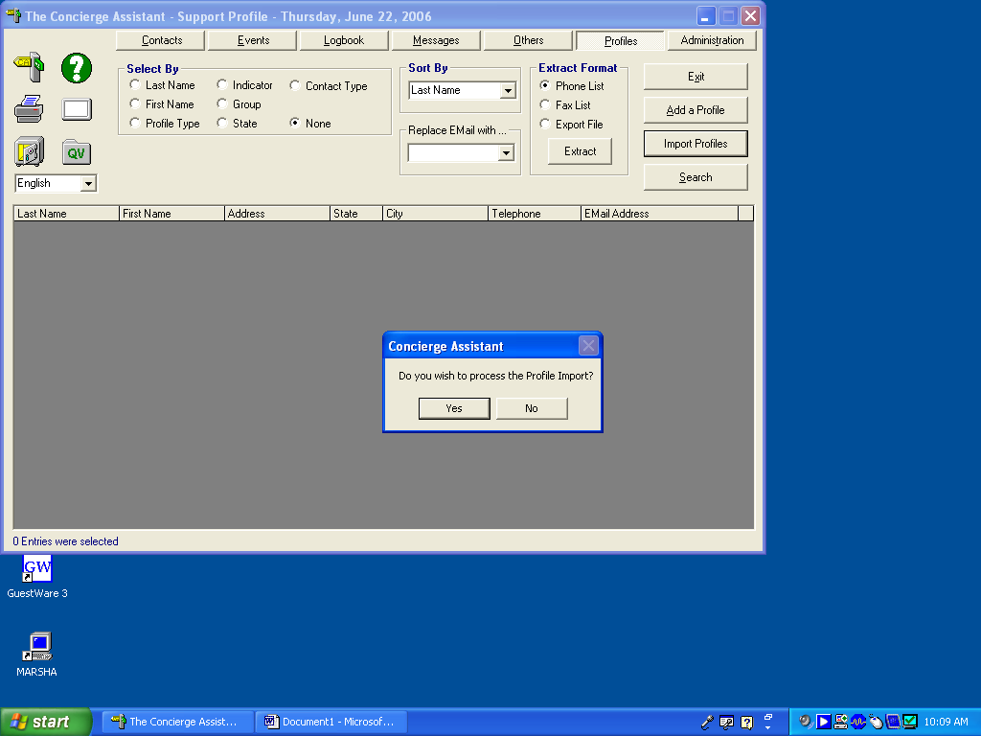

When you accept to import the profiles you will see if there are any files to be imported. To begin the import process double click on the file(s) listed in the screen shown below:

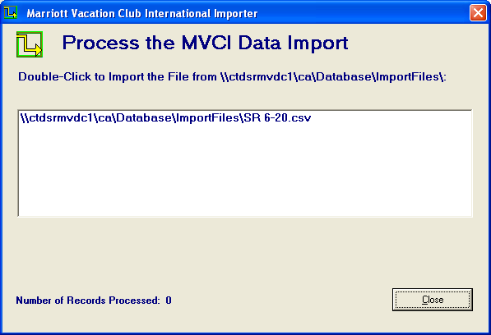

Once you double click the files you will see the files being uploaded to your database and when the process is finished you will see the number of records processed:

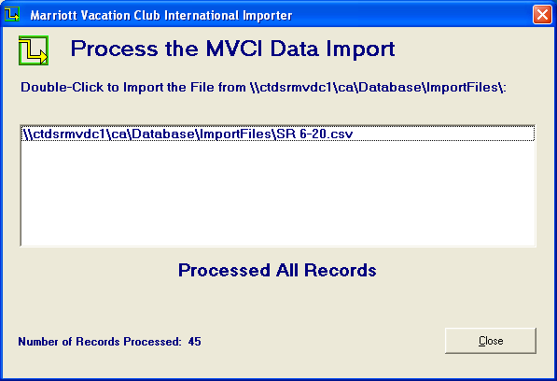

Now that the profiles are in your database they will show in color black.

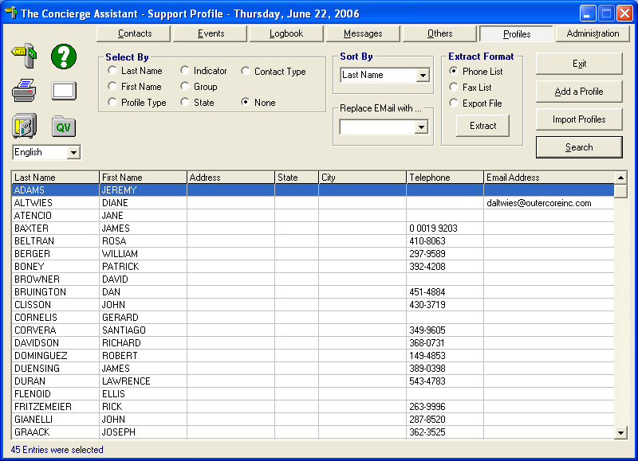

You are now ready to begin the Pre-calling Process
Pre-Calling Process

Select By indicator and from the drop-down menu select the indicator “arrival date” find the arrivals by typing the number of the next month followed by the forward slash e. a. 07/ (for July)

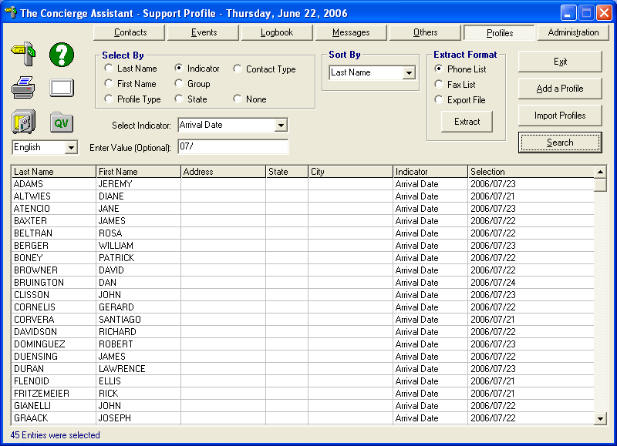

All the arrivals from the next month will be listed. If you don’t see all the records you downloaded. Type the next month number followed by the slash e. a. 08/ (for August)

Double click on the first record and go to the tab “Contact History”
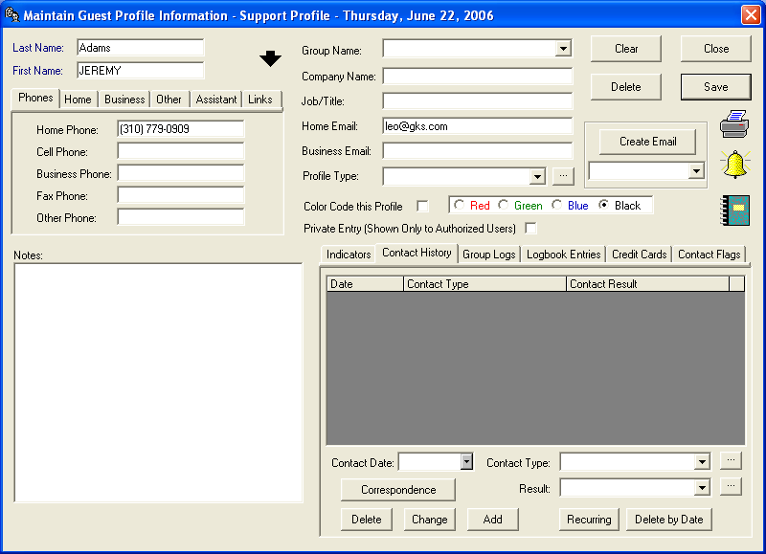
Fill out the contact date, contact type and result of the call and click Add

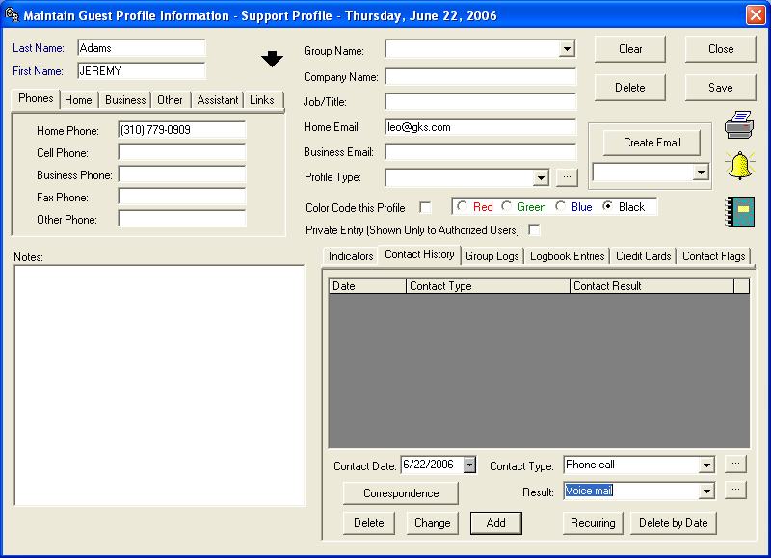

You will see the history listed in the window

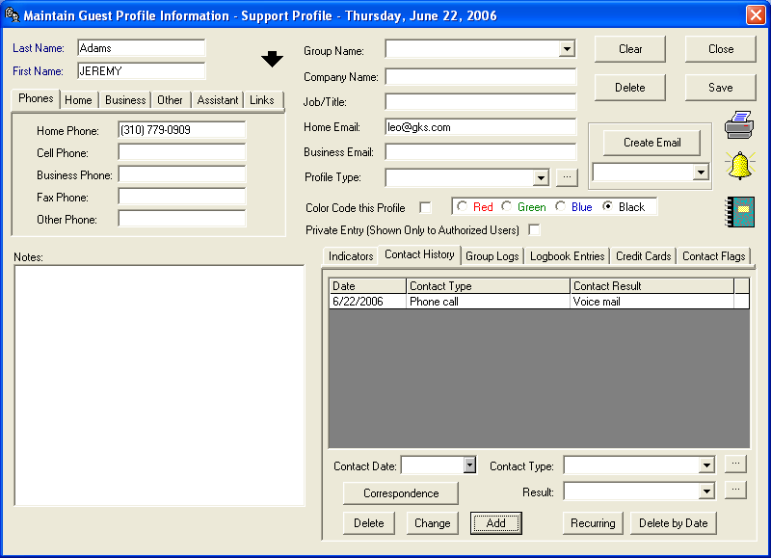
Once you contact the guest you may record the room preferences using the indicator SRQ
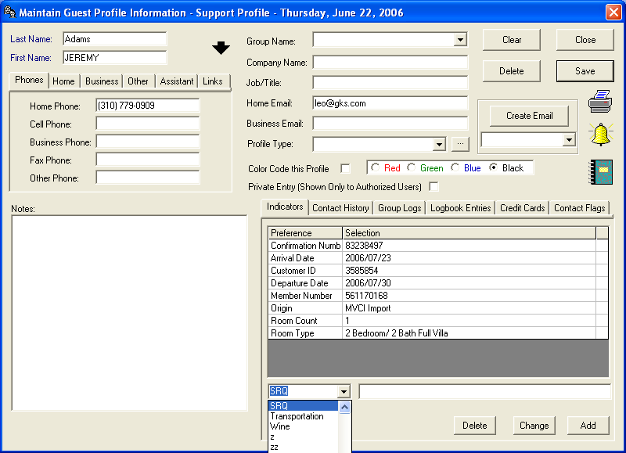

Once you record the preferences click Add
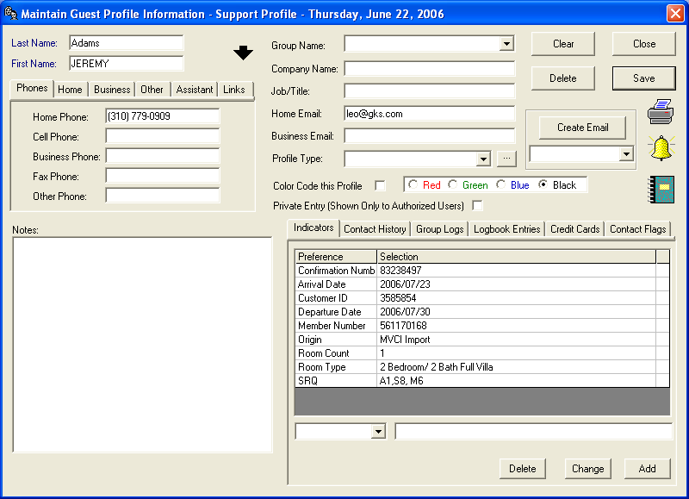

If you don’t remember the SRQ codes you may type the F6 key and search by keyword on your rolodex. Use the keyword “SRQ Codes”
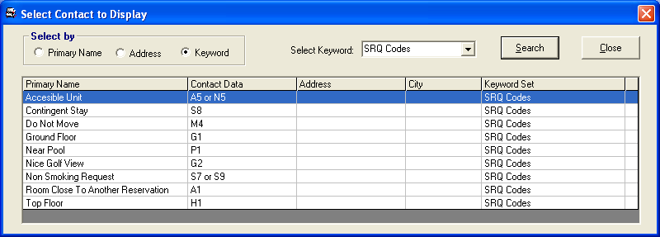
Once the call is completed and we have contacted the guest and recorded the preferences we need to color code this profile so everybody knows that the pre-calling process has been completed.

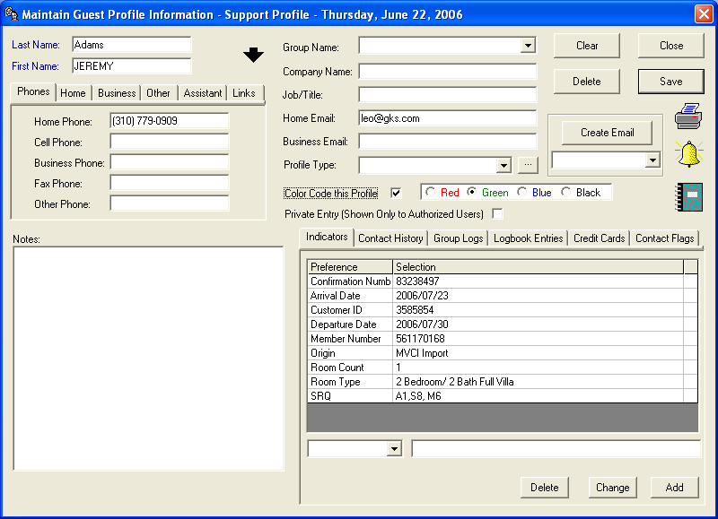

The profile will show in the selected color next time somebody searches this profile

